Water Alliance is a non-profit organization registered with the Community Development Authority in Dubai.

Water Alliance works to increase awareness of the global water crisis and spur a movement of sustainable living in the UAE.

www.wateralliance.org
@waterallianceuae
Student Ambassadors take an active role in promoting new thinking on sustainable water use and our consumer lifestyle.

Water Alliance provides a platform for interaction and action for students from different schools in the UAE.

Young students learn more about the Sustainable Development Goals and drive change within their circles of influence: at home, in school and with the broader community.

More about the program:
http://www.wateralliance.org/student-ambassadors/

WATER ALLIANCE
STUDENT AMBASSADOR PROGRAM
Dear teacher,

Your student is submitting an application to take part in the Water Alliance Student Ambassador program. She|He is showing exceptional leadership and will be mentored along with a selected group of fellow students as change agents. Places in this program are limited and your recommendation can make the difference during the selection process.

Kindly fill the recommendation template below and handle it over to your student in a PDF format.

For any query or further information about the program and Water Alliance, please don’t hesitate to contact Edurne at 0551527550 or edurne@wateralliance.org

Many thanks for supporting your student!
Please enter the information below using the spaces provided:
Please enter the information below using the spaces provided:
RECOMMENDATION LETTER
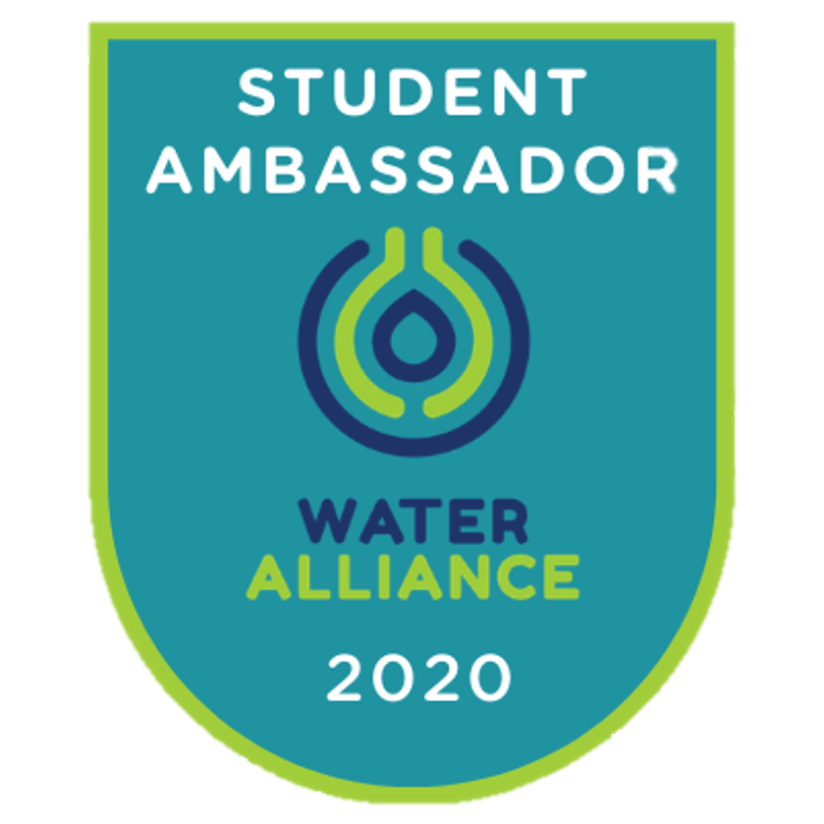
PAGE 1 OF 2
Email Address
SCHOOL
Phone Number
TEACHER’S NAME
GRADE | YEAR
STUDENT NAME

RECOMMENDATION LETTER

DATE:
SCHOOL:

I, NAME SURNAME, as a teacher of NAME SURNAME, recommend my student to be a member of the Water Alliance Student Ambassadors team as I believe that she|he can be a valuable contributor to the program.
PAGE 2 OF 2

STUDENT’S NAME has demonstrated excellent teamwork and independent thinking. She|he shows the following skills and abilities reinforcing her|his potential of becoming a change agent: PLEASE LIST

- x
- x
- x

AS RELEVANT:
STUDENT’S NAME has already been involved in activities supporting the environment at school. PLEASE DESCRIBE.

STUDENT’S NAME is a member or the School Eco-Club / other school club. (remove if not applicable)

I would also like to highlight STUDENT’S NAME project/event/assignment for which she|he deployed a strong can-do attitude, achieving an outstanding result. PLEASE DESCRIBE.

